NAME: ABDULKADIR SEMIRAH OJUOLAPE
MATRIC NUMBER: 17/SMS01/002
COURSE CODE: ECO 304
COURSE TITLE: PUBLIC SECTOR ECONOMICS

- THERE EXISTS A SHARP CONTRAST BETWEEN THEORIES OF PUBLIC EEXPENDITURE INCREASE EVEN AS POPULATION INCREASE WHILE SOME OPINED THAT NATIONAL EXPENDITURE INCREASES IN DEVELOPMENTAL STAGES. ARE THESE STATEMENTS TRUE ABOUT NIGERIA

DEFINATION OF PUBLIC EXPENDITURE
Public expenditure is spending made by the government of a country on collective needs and wants such as pension, provision, infrastructure, etc.
- INCREASE IN PUBLIC EXPENDITURE DUE TO INCREASE IN POPULATION GROWTH
It increases with the increase in population, more of investment is required to be done by government on law and order, education, infrastructure, etc. investment in different fields depending on the different age group is required. A high growth of population naturally calls for increase in the expenses as all State functions are to be performed more extensively. Rising population also poses various problems in poor countries. The State will have the added responsibility of solving such problems as food, unemployment, housing and sanitation. We see an expansion of geographical area of almost all countries. Even in no-man’s land one finds the activities of the modern government. Assuming a fixed size of a country, developing world has seen an enormous increase in population growth. Consequently, the expansion in adminis­trative activities of the government (like defence, police, and judiciary) has resulted in a growth of public expenditures in these areas.
- INCREASE IN PUBLIC EXPENDITURE DUE TO INCREASE IN DEVELOPMENTAL STAGES
The study investigated the effect of public expenditure on the growth and development of Nigerian economy (1980-2012). Three research hypotheses were formulated to guide the study. The hypotheses thus investigated the influence of aggregate expenditure, capital expenditure and recurrent expenditure on economic growth and envelopment in Nigeria. Ex-post facto research design was adopted for this study. Data were obtained from annual publications of Central Bank of Nigeria. Data gathered were analyzed using Ordinary least square multiple regression statistical technique. Result of the findings revealed that aggregate expenditure had a positive impact on economic growth and development of the Nigerian economy, recurrent expenditure had a significant relationship on the growth and development of the Nigerian economy. The result also indicated that capital expenditure also had a significant effect on the growth and development of the Nigerian economy. The study recommended that the government should increase its spending on components of public expenditure which will in turn promote investment in the country. Year in year out, the federal government allocate huge amount of money for the provision and maintenance of basic infrastructure like roads, schools, hospital etc. Travelling through Odukpani Calabar - Itu road in Cross River State, Nigeria you will discover that this road which is a trunk A road is a dead trap, most often people spend a whole day for a journey of not more than 1 hour, 30 minutes because of falling trucks due toextremely bad and narrow roads. According to Saberedow, (2009), Nigerian government spend huge amount of money on the development of social overheads, economic services and for the creation infrastructures for economic growth and most times, these funds are mismanaged, misappropriated, misplaced or even wasted, thus resulting in failed and incomplete execution of government projects. Throughout the years form 1980 till date government expenditure has continued to rise marginally on annual basis, yet no commensurate improvement on the economy.
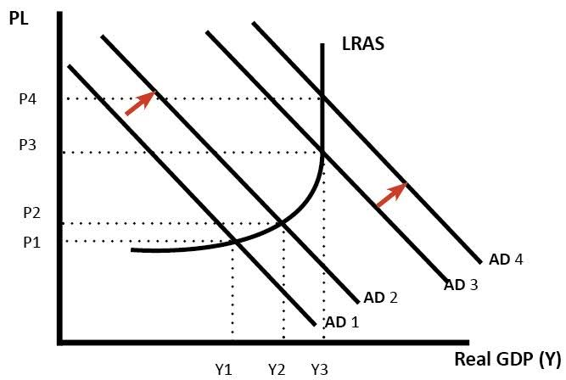
DIAGRAM FOR INCREASE IN PUBLIC EXPENDITURE

1B. YOU HAD BEEN CONTRACTED TO AS CHIEF ECONOMIC PLANNER OF THE STATE ON THE SUBJECT “ CORRUPTION IN NIGERIA IS ENDEMIC: CHALLENGES AND SOLUTIONS” , HOW DO YOU INTEND TO DELIGHT YOUR AUDIENCE?
Corruption is Nigeria's biggest challenge. It's clear to every citizen that the county has an extremely high level of corruption. Corruption is found in every sector of society. Critical examination of both small and large sectors reveals corrupt practices at every level.
DEFINATION OF CORRUPTION
What is corruption? It's dishonest or fraudulent conduct by those in power, typically involving bribery. It is the illegitimate use of power to benefit a private interest (Morris 1991). Corruption is the offering of a bribe to an official so that the truth will be hidden. It involves the embezzlement of public funds for personal use, and any act that is considered to be criminal in nature according to the law of a particular society.
Corruption is potent cancer that has mercilessly eaten Nigeria to a state of stupor.
— Professor Peter U. Nwangwu
PROBLEMS OF CORRUPTION

GREED
Greed has caused a lot of crises in the world, including in Nigeria. It is because of greed that political leaders embezzle the funds they are supposed to use for national development for their own selfish needs.

POOR YOUTH EMPOWERMENT
Poor moral youth empowerment is a contributor to corruption. Internet fraud, sexual harassment by male CEOs, and other bad acts occur because Nigerians lack understanding of the importance of youth empowerment. When parents and governments empower youths both financially and morally, the level of corruption will diminish.

POVERTY
According to international standards of poverty, a person is said to be poor when he lives under $1.25 (₦210, although it varies) per day. There are many poor people in Nigeria, and poverty pushes them into corruption. According to World Bank Group, in 2004, 63.1% of Nigerians were poor. The poverty level increased in 2010. In 2010, 68% of the Nigerian population was estimated to be poor. A person can take bribes to commit crime because he is poor. It is one of the reasons why the poor youths in the country collect bribes to work as thugs for Nigerian politicians.

UNEMPLOYMENT
Unemployment is one of the major challenges in Nigeria and does not need much explanation because it has broken the hearts of many citizens. People are pushed into corrupt practices because of the high unemployment rates. An unemployed citizen can indulge in corruption to make money and live better. The youths, fathers, and mothers are seriously concerned about the negative impact of unemployment in their lives. Some have said that it is better to die than to suffer the torment of unemployment in the country. Words cannot explain the level of punishment the citizens of this country face as a result of this menace.
EFFECTS OF CORRUPTION

POOR INVESTMENT
Unemployment in Nigeria would have been eradicated to some extent if only investors were attracted to doing business in the country. Companies that would have invested in Nigeria are afraid because they do not know if the corrupt practice will ruin their industries over time. Because of this concern, they refuse to invest in Nigeria.

RISE IN POVERTY
When the heads of public service are busy laundering the money that is supposed to be used to create employment for the masses and reduce poverty, what happens is a rise in the poverty level of the country, just like the rise in poverty shown by the statistics between 2004 and 2008. Since the government is selfish and does not want to help the poor, poverty continues to rise in Nigeria.

POOR NATIONAL DEVELOPMENT
Any country with high corruption levels is likely to experience developmental bankruptcy. When some CEOs indulge in corrupt practices to make their money, economic development will suffer. When Nigerians keep on shifting the country’s currency to foreign countries, there will be less economic development in Nigeria.

NATIONAL CRISES
So many crises in Nigeria today are a result of corruption. The insecurity in Nigeria brought about by Boko Haram is a consequence of corruption. Corrupt politicians are fighting the government of President Goodluck Jonathan using Boko Haram as their agent because they do not want him to succeed. The attacks by Boko Haram have caused disorderliness in Nigeria and seriously affected the country's economy.

POSSIBLE SOLUTIONS OF CORRUPTION

SELF SATISFACTION
Self-satisfaction in this context implies being content with what one has. When the leaders of Nigeria are satisfied with the salary they are paid and use public funds in a proper manner, the issue of embezzlement and money laundering will be history. Managers who are satisfied with what they are paid will not have time to indulge in corruption to make more money.

INSTITUTION OF STRONG ANTI- CORRUPTION GROUPS
Creating strong anti-corruption institutions is another arsenal to win the fight against corruption. This group is to work independently with the government to ensure transparency. Anyone who is caught engaging in corrupt practices by the group should experience the consequences decided by the anti-corruption agency. That he is a minister or governor of a state should not be an excuse from facing the punishment he is to receive according to the Constitution of Nigeria.

EMPLOYMENT GENERATION
The unemployed in the country find themselves involved in corruption mainly because they want to make money to meet the demand of the day. Governments and capable hands should endeavour to generate more jobs for citizens to get employed and paid in return. A busy mind may find it difficult to indulge in corruption because he is being paid adequately.

PROPER GOVERNMENT FUNDING OF SCHOOLS
Understanding the importance of skill acquisition will go a long way to propel them to develop all the schools in Nigeria. When more attention is paid to the tertiary institutions in the country, it will produce graduates who are employable. Installation of the necessary machines needed in universities will help Nigerian graduates acquire skills and use them to generate income, even if no company employs them after graduation. Self-employment will make graduates more determined in the work they do and will prevent them from corruption like Internet scams, kidnapping and the rest.

TREATING ALL CITIZENS EQUALLY
Treating any offender in the country equally will help reduce corruption. Nobody is above the law and any who acts contrary to it should be given the punishment that he or she deserves. That she is the Minister of Aviation or Governor of the Central Bank of Nigeria should not count in this case. If any minister or head of state is given the punishment he deserves for corruption, others will learn and separate themselves from any corrupt practice.

- CONCEPTUALIZE GOVERNMENT FAILURE. WHAT ARE THE SCENARIOS IN WHICH IT COULD OCCUR?
- GOVERNMENT FAILURE
This occurs when government intervention in the economy causes an inefficient allocation of resources and a decline in economic welfare. Government intervention to resolve market failures, and to manage the macroeconomy, can fail to achieve a socially efficient allocation of resources. Government failure is commonly defined as a situation where government intervention in the economy creates inefficiency and leads to a misallocation of scarce resources. The term originated in the 1960's when economists began to criticize any government intervention or regulation of the economy. At that time, economists who believed in laissez-faire capitalism argued that the free market was inherently efficient. They began to argue that government always created inefficiency, and was always a problem. These economists believed that government intervention often leads to government failure because it interferes with the invisible hand that guides the free market. First described by Adam Smith, the invisible hand is the result of individuals following their own self-interest in the economy often leading to positive outcomes for society. The invisible hand was the reason why competitive free markets distribute resources fairly. Individuals will try to improve their lives and become wealthier through buying and selling goods and services in the most efficient way possible. This will keep the market efficient, and improve social welfare. Although Adam Smith acknowledged that external forces and problems could disrupt the invisible hand, many economists maintain that the invisible hand will always create better outcomes than government no matter what. This is because government uses laws and regulations to force people to act against their self-interest. Some of these laws are great like outlawing murder, for example. However, other laws that force corporations to pay taxes are seen by some economists as limiting their profitability, and creating inefficiency.

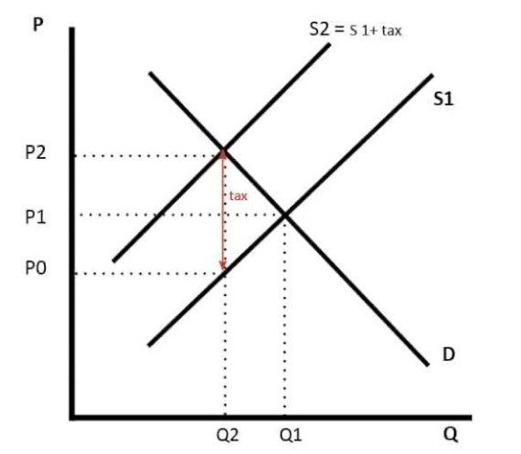
DIAGRAM FOR GOVERNMENT FAILURE

SCENARIOS IN WHICH IT OCCURS
- POLITICAL SELF-INTEREST
The pursuit of self-interest amongst politicians and civil servants can often lead to a misallocation of resources, For example decisions about where to build new roads, by-passes, schools and hospitals may be decided with at least one eye to the political consequences.
- REGULATORY CAPTURE
This is when the industries under the control of a regulatory body (i.e. a government agency) appear to operate in favour of the vested interest of producers rather can consumers. Some economists argue that regulators can prevent the ability of the market to operate freely. We might find examples of this in agriculture, telecommunications, the main household utilities and in transport regulation.
- DISINCENTIVE EFFECTS
Free market economists who fear government failure at every turn argue that attempts to reduce income and wealth inequalities can worsen incentives and productivity. They would argue against the National Minimum Wage because they believe that it artificially raises wages above their true free-market level and can lead to real-wage unemployment. They would argue against raising the higher rates of income tax because it is deemed to have a negative effect on the incentives of wealth-creators in the economy and generally acts as a disincentive to work longer hours or take a better paid job.
- POLICY DECISION BASED ON IMPERFECT INFORMATION
Often a government will choose to go ahead with a project or policy without having the full amount of information required for a proper cost-benefit analysis. The result can be misguided policies and damaging long-term consequences.

2B. PRESENTLY THE GLOBAL ECONOMIC IS WITNESSING A NOSE DIVE GIVEN THE PANDEMIC { COVID-19 }, DUE TO WIDESPREAD SHUTDOWN OF PRODUCTIVE ACTIVITIES IN BIG ECONOMIES, RESTRICTION OF MOVEMENT BY GOVERNMENTS, HUMAN CAPACITY DEVELOPMENT INHIBITIONS E.T.C AND YOUR HOME COUNTRY HAS DONE SAME. AS A SOCIAL CRUSADER AND SCIENCIST WILL YOU SUPPORT THE GESTURE IN NIGERIA? JUSTIFY YOUR ANSWER WITH PARCATICAL EXAMPLES.
To prevent the spread of COVID-19:
- Clean your hands often. Use soap and water, or an alcohol-based hand rub.
- Maintain a safe distance from anyone who is coughing or sneezing.
- Don’t touch your eyes, nose or mouth.
- Cover your nose and mouth with your bent elbow or a tissue when you cough or sneeze.
- Stay home if you feel unwell.
- If you have a fever, a cough, and difficulty breathing, seek medical attention. Call in advance.
- Follow the directions of your local health authority.
NB: Avoiding unneeded visits to medical facilities allows healthcare systems to operate more effectively, therefore protecting you and others.
For most developing economies, the odds of sliding into a downturn are gradually expected as the global coronavirus outbreak puts severe pressure on the economy. For Nigeria, the country is still sluggishly grappling with recovery from the 2016 economic recession which was a fall out of global oil price crash and insufficient foreign exchange earnings to meet imports. In the spirit of economic recovery and growth sustainability, the Nigerian federal budget for the 2020 fiscal year was prepared with significant revenue expectations but with contestable realizations. The emergence of COVID-19 and its increasing incidence in Nigeria has called for drastic review and changes in the earlier revenue expectations and fiscal projections. Compared to events that led to recession in 2016, the current state of the global economy poses more difficulties ahead as the oil price is currently below US$30 with projections that it will dip further going by the price war among key players in the industry. Unfortunately, the nation has grossly underachieved in setting aside sufficient buffers for rainy days such as it faces in the coming days. In addressing these daunting economic challenges, the current considerations to revise the budget downward is inevitable. Furthermore, cutting expenditures must be done such that the already excluded group and vulnerable are not left to bear the brunt of the economic contraction. The economic and growth recovery program which has the aim of increasing social inclusion by creating jobs and providing support for the poorest and most vulnerable members of society through investments in social programs and providing social amenities will no doubt suffers some setbacks. Besides, the downward review of the budget and contractions in public spending could be devastating on poverty and unemployment. Basically, the Nigerian government essentially must lead economic diversification drive. It is one practicable way to saddle through the current economic uncertainties and instabilities. What the consequences of COVID-19 pandemic should further offer the Nigerian economic managers and policymakers, is that the one-tracked, monolithic reliance on oil is failing. Diversification priorities to alternative sectors such as agriculture, solid minerals, manufacturing and services sectors, should be further intensified.

